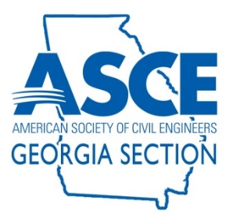

ASCE GEORGIA SECTION
2023-2024 Georgia Civil Engineering Awards
PROJECT NOMINATION FORM

SUBMITTAL DEADLINE May 10, 2024

- General Information:
Each year, the ASCE Georgia Section awards Projects of Merit to outstanding recently completed civil engineering projects throughout the state. These projects may be engineering studies, investigations, designs, or construction projects. See judging criteria listed below.
Project nominations may be completed by editing this form directly.
Winners will be notified on May 28, 2024. Projects of Merit will be celebrated at our annual banquet on June 21, 2024.

Entries Due: Friday, May 10, 2024

Send Entries and Questions To:

David Glassman
dglassman@massman.net

- Judging Criteria:
- Contribution to the well-being of people and communities
- Resourcefulness in planning and solving design challenges
- Pioneering in use of materials and methods
- Innovations in construction
- Impact on physical environment
- Beneficial as well as adverse effects of the project, including aesthetic value
- Unique Approaches and Partnerships – Did the project develop or utilize a unique approach or involve partnering with stakeholders in a non-traditional manner?
- Fiscal Responsibility – Did the project consider and improve the life-cycle costs or the long-term fiscal implications, and if so, how?
- Consideration of sustainability or maintenance
- Public outreach

- Project Information:
Project Name:
Project Location:
Completion Date:
- Nominating Party Information:
Submitted By:
Title / Role on Project:
Employer:
Phone:
Email:
ASCE Member (Yes or No):
- Engineering Firm Information (if applicable):
Company:
Contact Name:
Phone:
Email:
- Project Owner Information (if applicable):
Company/Entity:
Contact Name:
Phone:
Email:
- Contractor Information (if applicable):
Company:
Contact Name:
Phone:
Email:
- Project Information:
Project Description (1 paragraph):
Why Should This Project Be Recognized (1-3 paragraphs):

