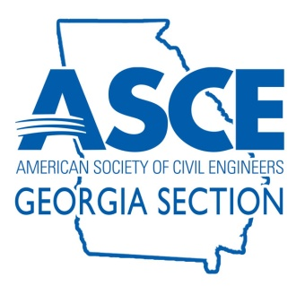
ASCE GEORGIA SECTION
2023-2024 Georgia Civil Engineering Awards

INDIVIDUAL NOMINATION FORM

SUBMITTAL DEADLINE May 10, 2024

- Qualifications:

- Nominee for Georgia Civil Engineer of the Year must be a licensed Professional Engineer, must be an ASCE member and must be a member of good standing with the ASCE Georgia Section.
- Nominee for Georgia Young Civil Engineer of the Year and Volunteer of the Year must be an ASCE member and must be a member of good standing with the ASCE Georgia Section. Registration as a licensed Professional Engineer is not required.
- Nominee for Georgia Student of the Year and Georgia Technology Student of the Year must be an ASCE Student Member of good standing.
- For all awards, Nominee’s primary place of employment must be in Georgia, and nominee must be a resident of the state. Nominee must be engaged in the practice of Civil Engineering in planning, design, construction, research, education, development, management, surveying, or related Civil Engineering work.

- Nominee

Nominee's Name:

Award for which member is nominated (“x” one):

Civil Engineer of the Year Category:

_________ Civil Engineer of the Year

_________ Young Civil Engineer (YCE) of the Year

_________ Student of the Year

_________ Technology Student of the Year

_________ Volunteer of the Year

Birthdate (Young Civil Engineer only): (Must be 35 years of age or less on 1/1/2024)

Company / School Name:

Job Title / School Year:

Primary Area of Civil Engineering Practice:

Georgia Registration Number (PE or EIT):

- Nomination Criteria

The following sections present the award nomination criteria that will be considered. The information can be typed and submitted as attachments to this form, or the information can be entered electronically, lengthening the form as needed. Nominees are encouraged to keep answers concise where possible.

1. Education: List Degree, Field, Institution, and Date for each post High School degree earned. Note if degree was pursued but not completed (10 Points).

2. ASCE or ASCE Institute Involvement: ASCE and ASCE Institute activities during the past five years, including offices held and awards (10 Points).

3. Professional/Technical Society Involvement: Other professional/technical society activities during the past five years, including offices held and awards (10 Points).

4. Civic and Humanitarian Organization Involvement: Civic and humanitarian organization activities in Georgia during the past five years, including positions held (10 Points).

5. Publications: List of Articles Published or Technical Presentations presented during the past five years. Include article and publication titles, date, and publisher information for articles or books, and presentation title, location(s) presented, and number of times presented (10 Points).

6. Engineering Achievements: Submit narrative supporting nominee’s project achievements (40 Points).

7. Endorsement: Minimum of one and maximum of three letters of endorsement from peers and fellow engineers with specific firsthand knowledge of the nominee's engineering accomplishments (10 Points).

8. Professional Registration in Other States: List registration type for each state and year first registered (Bonus, 5 points maximum).

- Additional Requirements:

- A resume would be helpful to the judges but is not obligatory.

- NOTE: A photograph and short written statement (to be included in Awards Banquet Program) will be required from the winning nominees.

- Submittal Requirements

Submittal Deadline: May 10, 2024

Send the completed nomination package and any questions to:

David Glassman
dglassman@massman.net

- Award Presentation

Award winners will be contacted May 28, 2024.

Awards will be presented at our annual banquet on June 21, 2024.

