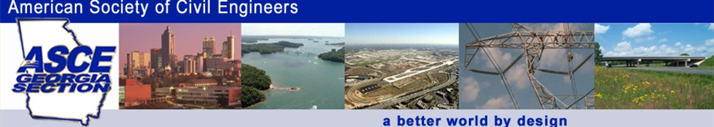

Money Magazine recently ranked civil and environmental engineers as the # 6 and # 5 best jobs in America! So what does that mean? And why should you care? Did you know that civil engineers actually make life easier for people around the world, and here at home? Their work improves the quality of life for people.

The Georgia Section of American Society of Civil Engineers (ASCE) wants to stimulate your thinking about that question by sponsoring a contest to answer the question “What DO Civil Engineers Do? You can write an essay or a poem, perhaps prepare a painting or drawing, even create a physical model…whatever you decide to demonstrate your perception of what civil engineers do.

Don’t know where to start? Check out our ASCE Ga. website at www.ascega.org to find a variety of resources, interactive tools and cool stuff to help get you going. Want MORE help? Contact John Pierson to connect with REAL civil engineers who can meet with you or your team, help you brainstorm or put you in contact with civil engineering students. Final entries will be due on Thursday, March 23, 2017.
Contest Rules and Guidelines

General Rules
- You must prepare an original entry (written story, essay or poem, or a work of art, etc.) that answers the question, “What DO civil engineers do?” Evidence of plagiarism will be grounds for disqualification.
- Entries can be individual, or teams of up to 3 members. The use of social media in the project is highly encouraged.
- Written works cannot exceed 800 words.
- Artwork can be no larger than 20 inches x 20 inches (x 12 inches depth). Entries not meeting this requirement will be penalized.
- Presentation type works are limited to 8 minutes.
- Cost of materials used for any entry should not to exceed $50.

Judging of Entries
- Judging of written works will be based on the following:
- A logically ordered, clear, coherent theme and factual statements that develop and build on the theme.
- Works must express and clarify at least two different types of work undertaken by civil engineers and the impact of their work on people.
- Essays and stories shall use Standard English in complete sentences, following standard grammatical rules, including correct spelling and punctuation.
- Poems must provide illumination of the theme expressed, presented clearly enough to be understood by the panel of judges.
- Judging of art entries will be based on the following:
- Project must clearly define an understandable theme, and illustrate it clearly through artistic expression.
- The art entry must exhibit at least two different types of work undertaken by civil engineers and clearly illustrated the impact of their work on people.
- Artwork must be permanent and non-fragile, with appropriate use of color, form, texture and possibly function.
- The entry for each grade category (6th, 7th and 8th) which best expresses and describes the work done by professional civil engineers and the impacts of their work will be determined as the winner. All judges’ decisions will be final.

Submitting Entries
- ALL entries must be received ON OR BEFORE Friday, March 2nd, 2012 by 5:00 PM, EST.
- Registration of the entry should be performed directly on the ASCE GA Section website contest form as soon as possible. When the project is ready for submittal, they can be e-mailed or dropped off as described below.
- Most entries (such as essays) can easily be emailed to contest@ascega.org. Any electronic submittals should conform to standard file formats (DOC, XLS, PPT, PDF). Contact the Georgia Section through the contest email to arrange delivery of larger scale physical entries that cannot be delivered via e-mail (i.e. models, artwork, books, electronic files >10 MB, etc.). Large files unable to be e-mailed can be physically submitted on a “flash” or “jump” drive in the same manner. Physical projects may be returned to the registrant following the end of the contest if desired.
- All entries should have the “Name” of the entry that it was originally registered with either written somewhere on the entry documents or physical work along with your name and school No entries will be accepted without this identification on it.

Categories of Awards
- Cash awards will be given to the winners respectively of sixth grade, seventh grade and eighth grade entries totaling 9 awards. (Note however, the program committee reserves the right to consolidate or adjust categories/awards depending on the numbers of entries or in the event of tied entries) Home-schooled students’ entries will be accepted with certification of grade level.
- Each 1st-place winners will receive $150 cash, each 2nd-place winners shall receive $100.00 cash, and each 3rd-place winners will receive $50 cash.
- Awards will be distributed at the ASCE Georgia Section May Meeting held on May 5th at the Carlyle House in downtown Norcross. Admission to the event will be covered for the winners and one parent/guardian to attend this recognition ceremony.

How can you get more help to develop your entry?

Log on to www.ascega.org or any of the following websites to learn more:

ASCE National’s ASCEville: http://www.asceville.org/ Discover Engineering http://www.discovere.org/discover-engineering Engineering Girl http://www.engineergirl.org/ Engineer Your Life http://www.engineeryourlife.org/
Contact John Pierson, P.E. and arrange a personal visit or meeting with REAL practicing civil engineers, or engineering students.

For general information or additional questions regarding the competition, contact us at contest@ascega.org.

